**Report Summary**

The purpose of this report is to seek approval of £4,999,063 from the North East Combined Authority (North East CA) to progress essential infrastructure works in the Forth Yards regeneration area across two elements - Pottery Lane widening (£4.27m) and facilitating works for the Newcastle Highline (£0.73m). The Pottery Lane widening will remove the width constraint on the current highway, adjacent to sites with the focus for early development on the eastern side of the regeneration area. The proposed Highline is a critical part of the area’s active travel infrastructure, connecting the city centre to the future Forth Yards neighbourhood and to existing communities.

**Recommendations:**

The Chief Executive, in consultation with the Mayor, relevant Cabinet Member and the Finance and Investment Board, is recommended to:

1. Approve £4,999,063 of Trailblazer funds to Newcastle City Council for the Forth Yards scheme set out in the report.
2. **Context:**

Delegated Decision was authorised at Cabinet on the 11 June 2024 (C13/6/24 North East Deeper Devolution Deal – Ratification and Next Steps).

Forth Yards represents a once in a generation major strategic place making opportunity in what is the last major undeveloped water frontage area of the city of Newcastle and is a key element to the rejuvenation of the river as being brought forward by both Newcastle City Council and Gateshead Council. The site, in the west end of Newcastle, adjacent to Central Station, has long been blighted by contamination and mixed minor land ownership and is a particularly challenging brownfield site to develop.

The scheme will present a western gateway into the city centre and communities in the inner west and is now coming forward, driven by a public sector partnership model. Once complete, it will deliver 20ha of Brownfield Land developed; over 3500 new Housing Units; and 350,000sqft of new commercial floor space, as well as community facilities; new public realm and sustainable transport infrastructure; a site wide district heating network; new education space; and new local health facilities.

The whole site is being brought forward by a public partnership of Homes England, Network Rail, Newcastle City Council and the Combined Authority, alongside individual developers or a development consortium at a later date. A Memorandum of Understanding between the public partners was signed in February 2023.

1. **Background Information, Proposals and Timetable for Implementation**

|  |  |
| --- | --- |
| **Proposal Name** | Forth Yards enabling works |
| **Lead Organisation** | Newcastle City Council |
| **Delivery Areas** | West Central Newcastle |
| **Timescales** | June 2024 – June 2025 |
| **Project Value** | £4,999,063 |
| **Grant amount requested** | £4,999,063 |
| **NTCA Budget Implications:** | North East CA have agreed a £5m Trailblazer Fund capital allocation at Cabinet on June 11th 2024, consistent with the North East CA’s devolution deal. |

* 1. Timetable:

|  |  |
| --- | --- |
| Start Date | June 2024 |
| Financial Completion | January 2025 - Date by which the widening and the pieces of Highline feasibility can be fully contracted and payment made |
| Date by which all outputs and outcomes will be achieved | October 2025 - Date of full and final completion of the road widening and Highline investigation work. |

* 1. Project delivery summary:

Forth Yards represents a once in a generation strategic placemaking opportunity on what is the last major area of underdeveloped water frontage in Newcastle and one of the region’s most challenging brownfield sites. The city is the strategic hub to the region and this site, within close proximity to Newcastle Central Station, represents a western gateway into the city centre and the communities in the inner west.

The regeneration area comprises 21 hectares and has capacity for circa 3,500 homes, commercial space and other uses. The site is complex, comprising fragmented largely (at least until the Homes England acquisition of Quayside West) private land ownerships and challenges of a common infrastructure requirement and significant abnormal costs which create a viability challenge.

The Forth Yards site is located close to the city centre but, due to topographical constraints and the legacy of former uses, it is poorly connected with the surrounding environment. Walking and cycle links to the city are constrained by busy roads with limited safe crossing opportunities and by the steep routes between Forth Yards and the river.

Improving transport access to Forth Yards will help to stimulate development. This will be achieved through junction improvements, road widening schemes and new highways and will also create an attractive environment for pedestrians and cyclists.

The submitted business case seeks funding to progress essential infrastructure works across two elements - Pottery Lane widening and facilitating works for the Newcastle Highline (see Appendix for a figure).

1. Pottery Lane Widening
2. Newcastle Highline Facilitating Works
   1. Pottery Lane widening:

The widening of Pottery Lane has been identified in a number of statutory and wider strategic documents[1] as an essential first step in the programme of infrastructure improvements to support the progression of development sites in the Forth Yards area. Pottery Lane provides access to the eastern edge of the Forth Yards Site from Forth Banks through the rail viaduct linking King Edward Bridge to Central Station and separates Forth Goods Yard from the Pottery Lane West residential site.

Newcastle City Council has identified that the width constraint on Pottery Lane is a major infrastructure constraint on sites with potential for early development on the eastern side of the regeneration area, Forth Goods Yard and Pottery Lane West. Vehicular access to these sites will be via Pottery Lane, necessitating its widening, improvement and realignment.

Development on these eastern sites will only be forthcoming on the basis of the City Council’s commitment to address this infrastructure constraint. Additionally, the Pottery Lane widening also has a critical role to play in supporting the delivery of other sites in the Forth Yards opportunity area.

* The acquisition of the Quayside West site by Homes England will require improved access short term (construction traffic) and long term (residential population). Homes England are progressing swiftly to identify a delivery model and move the site forward to delivery.
* Government [DESNEZ] funding for a localised District Heating Plant will be focused on this area and needs to start on site by 2025. The works to widen of Pottery Lane will enable heat network and other key services infrastructure to be introduced within the highway.

Scoping works have been undertaken by Newcastle City Council to enable the swift delivery of the widening and enhancement works. A detailed scheme design is complete which identified £4,269,063, which is now is sought to deliver the following:

* Pottery Lane (Widening) – Civils & Surfacing
* Forth Banks Junction – Traffic Signals and surfacing
* Redheugh Bridge Road – Traffic Signals and surfacing
* Street Lighting
* HVM (Redheugh Bridge Road) & associated pedestrian crossing
* District Energy Infrastructure
  1. Highline Facilitating Works:

The Newcastle Highline will be a high-quality elevated linear park and segregated active travel route on a 1.6 km stretch of the former Forth railway branch. The route will span the northern boundary of the site between Newcastle Central Station, Forth Yards and extending westwards to Newcastle Business Park, along with intermediate links to existing active travel routes.

This will provide the opportunity to connect the city centre to the future Forth Yards neighbourhood and existing communities to the east. It is a key part of the green infrastructure and connectivity to create a high quality, low carbon, low car neighbourhood in a gateway location in Newcastle.

Significant preparatory and scoping work has been undertaken to identify options. An options appraisal study was undertaken in March 2024. In order to progress the options appraisal to deliver, manage and maintain the Highline, a significant amount of supporting information is required, specifically related to any abnormal costs associated with its development.

The Highline corridor and the areas bounding it have an extensive and varied history of potentially contaminative land uses. Whilst information on the ground conditions for the surrounding sites is available, there has been no investigative work undertaken on the Highline corridor itself. To fully assess the abnormal costs associated with developing the Highline, investigative work will need to be commissioned. The work will establish the remedial/mitigation activities required to address contamination and ground gas risks and to undertake an assessment of bridges and supporting structures. Early funding is therefore essential to undertake these works.

£730,000 is now sought from the North East CA for these further investigative works. A large number of feasibility studies and further work has been identified as necessary for this scheme including design works, ground and environmental assessments.[2]

Contracting of works will take place within the 2024/25 financial year, with delivery in 2025/26.

1. **Funding profile:**

2.1 Breakdown:

|  |  |
| --- | --- |
|  | **FINANCIAL VALUE** |
| **Trailblazer Capital Grant** | £4,999,063 |
|  |  |
| **TOTAL NECA FUNDING:** | £4,999,063 |
| N/A |  |
| **TOTAL MATCH FUNDING:** | £0 |
| **TOTAL PROJECT COST:** | £4,999,063 |
| **Intervention Rate** (NTCA £ ÷ Total Project £ = IR %) |  |

* 1. No match funding has been provided by Newcastle City Council for this specific intervention. However, it is important to note that as part of the council’s collaborative approach to the Forth Yards opportunity with Homes England, Network Rail, North East CA and DLUHC, substantial resource has been put towards the delivery of the Forth Yards vision to date. Whilst these contributions sit outside this project, their added value provides a level of justification for the lack of direct match funding.
  2. Value for Money Summary

On the basis of the information provided by Newcastle City Council and the associated analysis, the appraisal summary table is displayed below.

|  |  |  |
| --- | --- | --- |
|  |  | **Preferred Option** |
| A | Present Value Benefits - Initial (£m) | £10,581,455 |
|  | Land Value Uplift | £10,581,455 |
| B | Present Value Benefits - Adjusted (£m) | £11,983,522 |
|  | Removal of brownfield disamenity | £11,983,522 |
| C | Present Value Costs (£m) | £7,128,664 |
|  | Net Present Public Value (£m) [A-C] or [A-C+B] | £15,436,313 |
|  | Initial Benefit-Cost Ratio [A / C] | 1.48 |
|  | **Adjusted Benefit Cost Ratio [(A + B) / C]** | **3.17** |
|  | Vfm category | Good (BCR >2) |

The Adjusted BCR demonstrates that the scheme delivers good value for money (over 2:1), when the wider impacts of the proposal are considered, such as the removal of brownfield disamenity for surrounding households

1. **North East CA Outputs/KPIs:**

3.1 Outputs from the project

The direct project outputs from the intervention will be the Pottery Lane widening and enhancements.

Newcastle City Council has identified that the Pottery Lane widening will unlock the Pottery Lane West site. The site comprises 3.15ha brownfield land on Pottery Lane, with the capacity to deliver 519 new housing units by Autumn 2026. This a longstanding brownfield site with accessibility issues that would not progress without the proposed infrastructure works.

The benefits are therefore:

* 1 km road improvements
* District Heating Plant infrastructure
* 3.15ha brownfield land redeveloped
* 519 housing units
* 1,609 indirect construction jobs supported (using Homes England [Fact Sheet 8](https://assets.publishing.service.gov.uk/media/65324c17e839fd001486724b/Fact_sheet_8._Economic__social__environmental_benefits.pdf)**)**

3.2 Outcomes/benefits of proposed intervention.

* Direct land value uplift
* Removal of brownfield disamenity as a result of the redevelopment.
* Improved accessibility and permeability of the eastern side of the regeneration area.
* Improved perceptions by businesses, residents and visitors.

**4.**  **Appraisal and Conditions:**

The Business Case submission, prepared by Avison Young for Newcastle City Council, has also been fully appraised by the independent surveyor Nigel Wilcocks of Mickledore. The submission was given an overall ‘Green’ rating. The only area highlighted as needing more focus was on the development of wider economic benefits, which is not unusual on a significant Capital Expenditure scheme. The conditions below were devised to respond to points raised in appraisal:

Should North East CA approve project funding, the following conditions are proposed as part of any funding agreement:

* Condition 1: A fully completed and signed application is required.
* Condition 2: A funding condition should state that any funding overrun is the responsibility of NCC (as agreed during appraisal).
* Condition 3: A performance condition could be included setting out the requirement for all the elements of the scheme to be completed – notably the district heating infrastructure within the road design.
* Condition 4: The applicant to work with the Combined Authority on identifying all potential economic benefits that could be secured.

The Subsidy Control assessment was undertaken by Alex Rose of specialist DWF. They outlined that the Grant can be awarded on a "no subsidy" basis. In their view, the Council is not an enterprise for the purposes of receipt of this funding to undertake investigations to create the Highline (which will be a high level urban park and pedestrian route) as this is not what would be classed as *economic activity*. This means the Council will not be an enterprise in receipt of this funding hence one of the key requirements for a finding of subsidy is not met. While investigations relating to the delivery of new pedestrian routes and the actual widening of Pottery Lane West will amount to general public infrastructure, given that the works are needed to meet the demands of the new and local population. It is noted that this will also have the secondary benefit of enabling a neighbouring site to be developed but this is an incidental benefit of the type that arises from most general public infrastructure projects that should not compromise the overall finding of no subsidy.

1. **Impact on North East Combined Authority Objectives:**

These projects relate to supporting economic activities via trailblazer funding, which are highlighted in the Devolution Deal, with the Forth Yards area designated as a major strategic site to deliver significant new homes and new economic activity within the Combined Authority area.

1. **Key risks:**

A full RAG assessment and risk register has been submitted alongside the Business case. The risks associated with this application (delivery of a capital works programme, on time and to budget) are mitigated through funding conditions. These include project phasing and associated progress assessment, and the ability for funding clawback and/or the applicant having to cover any cost overruns identified.

1. **Financial and other resources implications:**

The allocation for this project was identified within the Trailblazer Devolution agreement, allocating £5million from central government to deliver a time bound one off capital works programme by end March 2025. This allocation was set out and approved at Cabinet on 11 June 2024.

1. **Legal implications:**

The comments of the Monitoring Officer are included in the report.

1. **Equalities implications:**

North East CA is committed to driving equality and diversity. The measures contained within this paper will help meet duties under the Equality Act 2010, particularly around advancing equality of opportunity for those with protected characteristics, particularly with regard to socio-economic background.

1. **Consultation and engagement:**

Extensive consultation is underway locally in West central Newcastle, via the Council and their wider partners (particularly Homes England), and with all relevant stakeholders, pertaining to the future regeneration of the Forth yards area.

1. **Appendices:**

Attached below is a technical drawing, outlining details of the location and nature of the works, as requested at the Technical Officers Group meeting on 1 July 2024.

1. **Background papers**

Cabinet Decision Notice - 11 June 2024.pdf

1. **Contact officers:**

Ian Freshwater, Senior Regeneration and Economic Development Officer

1. **Glossary**: N/A
2. **Sign-off**

|  |  |  |  |
| --- | --- | --- | --- |
| 1. Cabinet Member:   Yes | 1. Director/Head of Service: Yes | 1. Director of Finance and Investment:   Yes | 1. Monitoring Officer:   Yes |

**APPENDICES:**

Mott MacDonald | Forth Yards Infrastructure Delivery Revised Draft Report

Figure 1: Forth Yards study area and location of the Pottery Land and Proposed Highline schemes

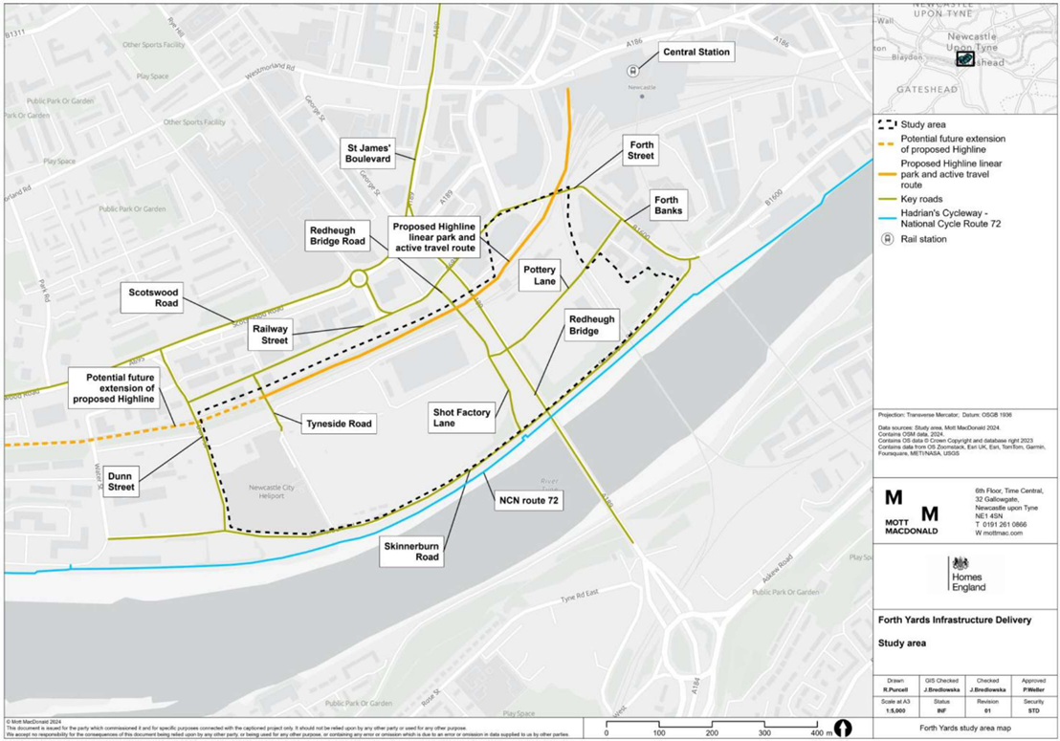

Source Mott MacDonald, Cushman & Wakefield

100117503 | 1 | C | | April 2024

1. Newcastle City Council’s 2020 Forth Yards Development Framework, Policies D1 and D3 of the Newcastle Local Plan and the 2024 Forth Yards Infrastructure Delivery Strategy.
2. This includes: Network Rail ASPRO procedures / Network Change; Planning consultancy / LPA pre-app meetings; Detailed investigation of adjacent land ownership; Feasibility option designs; Feasibility cost estimates; Branding and comms strategy; Detailed viability appraisal modelling; Topographical survey; Ground investigation; Structural surveys of existing viaduct and bridges; Management options/financial business plan; Strategic Outline Case including economic appraisal and financial modelling; Services/utility survey; Ecology survey; Heritage assessment; Drainage survey; Arboriculture survey; Lighting assessment; Air quality survey; Noise survey; Flood risk assessment.